EXP 01
1. Scenario: You are working on a project that involves analyzing student performance data for a class
of 32 students. The data is stored in a NumPy array named student_scores, where each row represents
a student and each column represents a different subject. The subjects are arranged in the following
order: Math, Science, English, and History. Your task is to calculate the average score for each subject
and identify the subject with the highest average score.
Question: How would you use NumPy arrays to calculate the average score for each subject and
determine the subject with the highest average score? Assume 4x4 matrix that stores marks of each
student in given order.

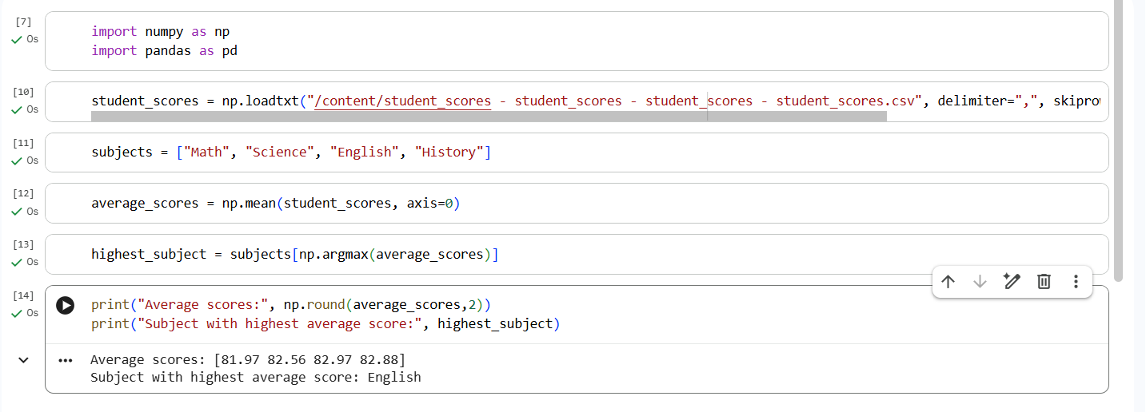

EXP 02
2. Scenario: You are working on a data analysis project that involves analyzing the monthly
temperature and rainfall data for a city. You have a dataset containing the monthly temperature and
rainfall values for each month of a year. Your task is to develop a Python program that generates line
plots and scatter plots to visualize the temperature and rainfall data.
Question: 1. Develop a Python program to create a line plot of the monthly temperature data. 2:
Develop a Python program to create a scatter plot of the monthly rainfall data.

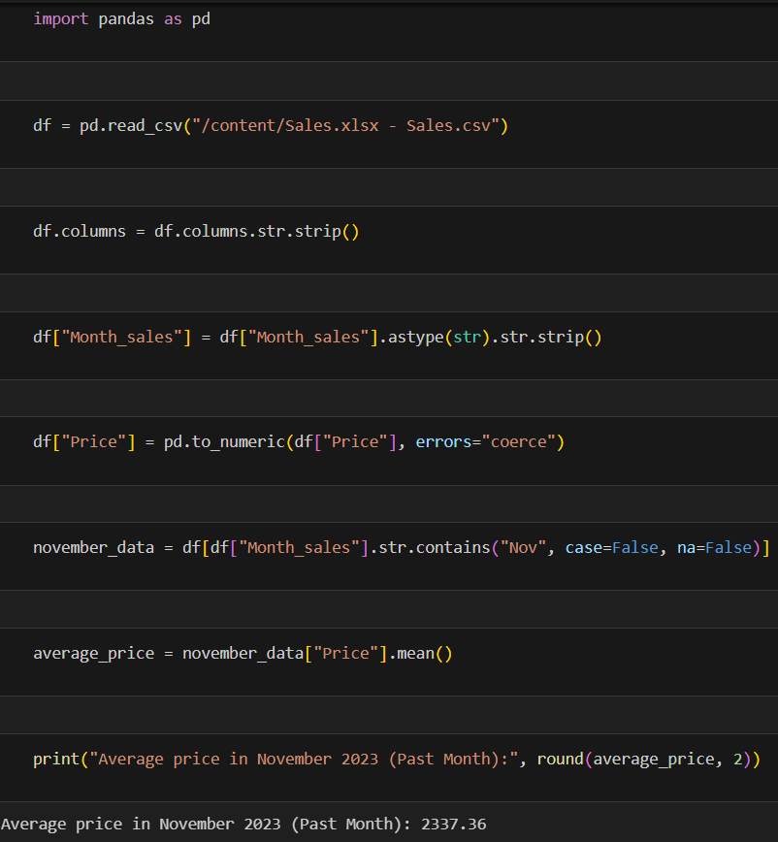

EXP 03
3 . Linear Regression for Housing Price Prediction You are a real estate analyst trying to predict
housing prices based on various features of the houses, such as area, number of bedrooms, and
location.
You have collected a dataset of houses with their respective prices. Write a Python program that
allows the user to input the features (area, number of bedrooms, etc.) of a new house. The
program should use linear regression from scikit-learn to predict the price of the new house based
on the input features.

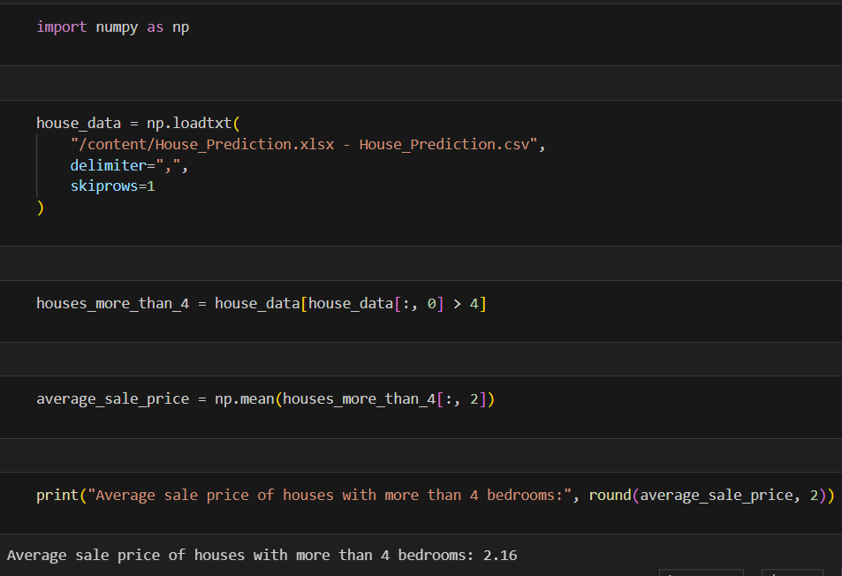

EXP-4 :
4. Scenario: You are working on a project that involves analyzing the sales performance of a
company over the past four quarters. The quarterly sales data is stored in a NumPy array named
sales_data, where each element represents the sales amount for a specific quarter. Your task is to
calculate the total sales for the year and determine the percentage increase in sales from the first
quarter to the fourth quarter.
Question: Using NumPy arrays and arithmetic operations calculate the total sales for the year and
determine the percentage increase in sales from the first quarter to the fourth quarter?

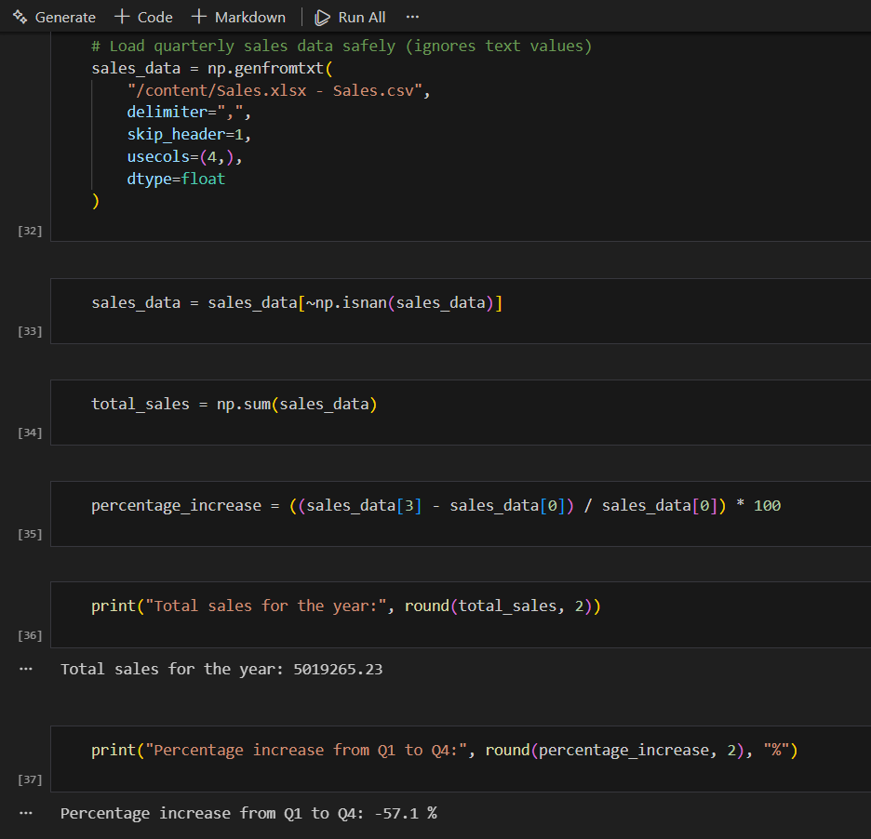

EXP-5 :
5. Scenario: You are a data analyst working for a car manufacturing company. As part of your
analysis, you have a dataset containing information about the fuel efficiency of different car
models. The dataset is stored in a NumPy array named fuel_efficiency, where each element
represents the fuel efficiency (in miles per gallon) of a specific car model. Your task is to calculate
the average fuel efficiency and determine the percentage improvement in fuel efficiency between
two car models.
Question: How would you use NumPy arrays and arithmetic operations to calculate the average
fuel efficiency and determine the percentage improvement in fuel efficiency between two car
models?

